Java FSE – Hands on Assignment
Name: Angarag Seal
Email: angaragseal55@gmail.com
Week -1
Exercise 1: Implementing the Singleton Pattern

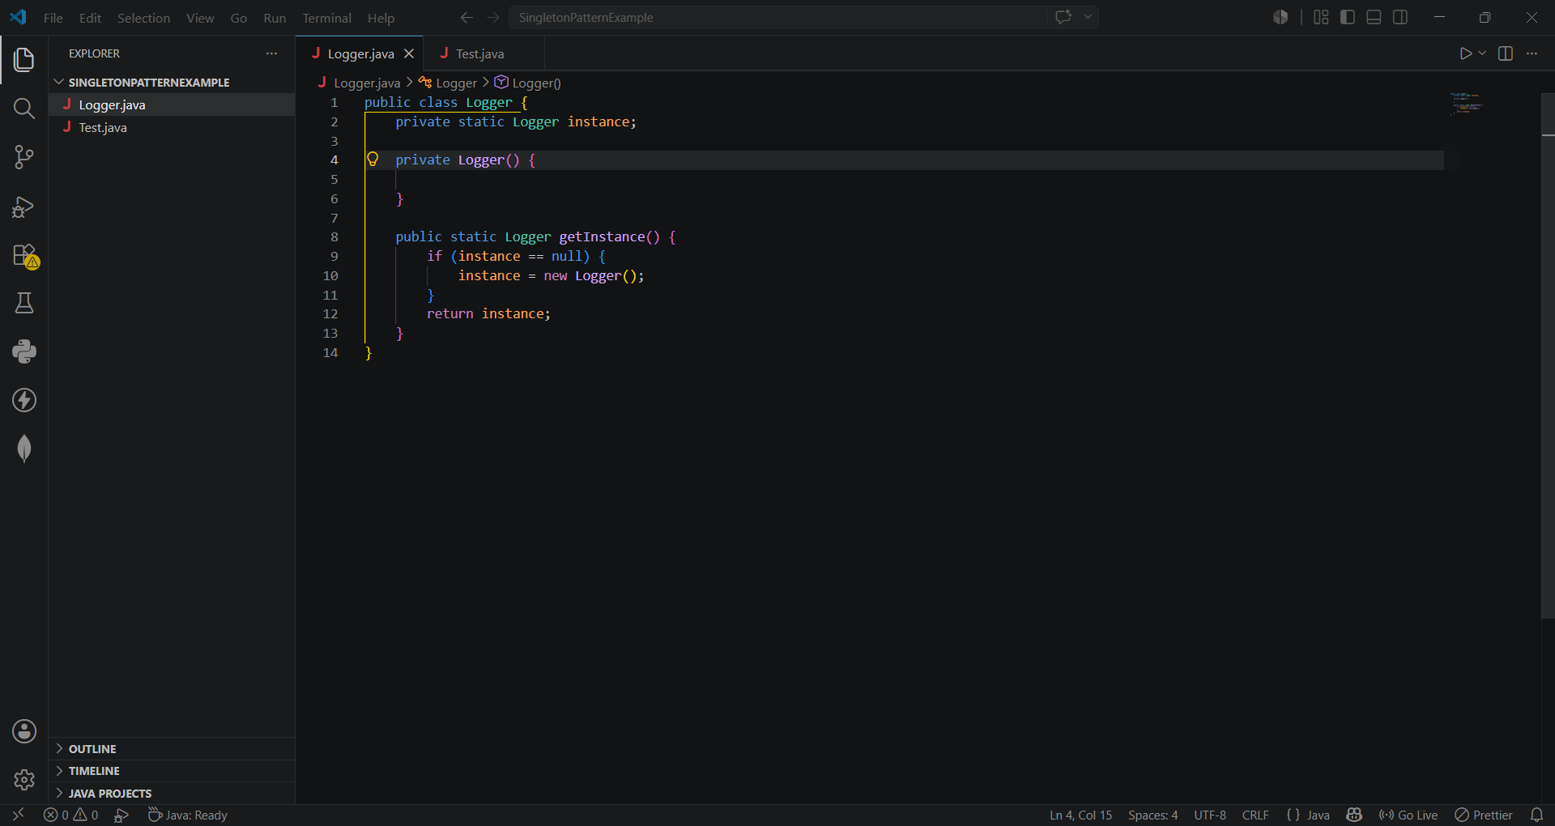

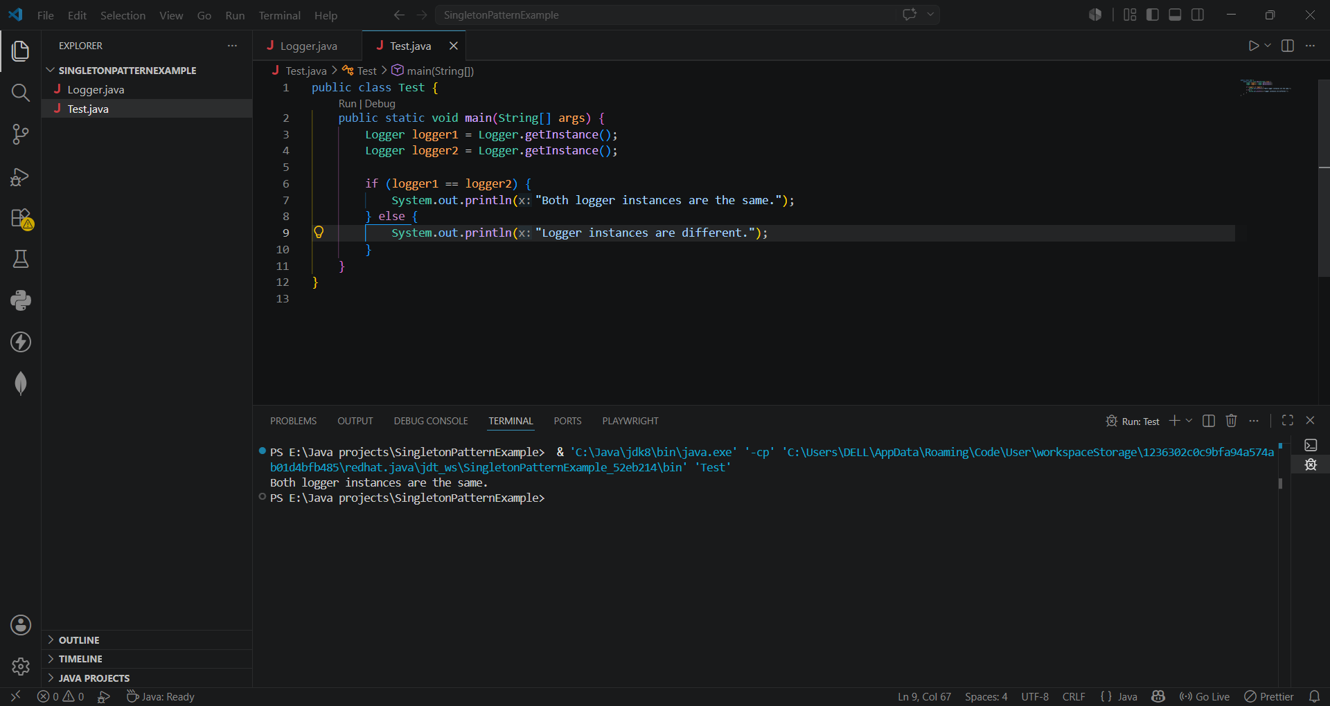

Exercise 2: Implementing the Factory Method Pattern

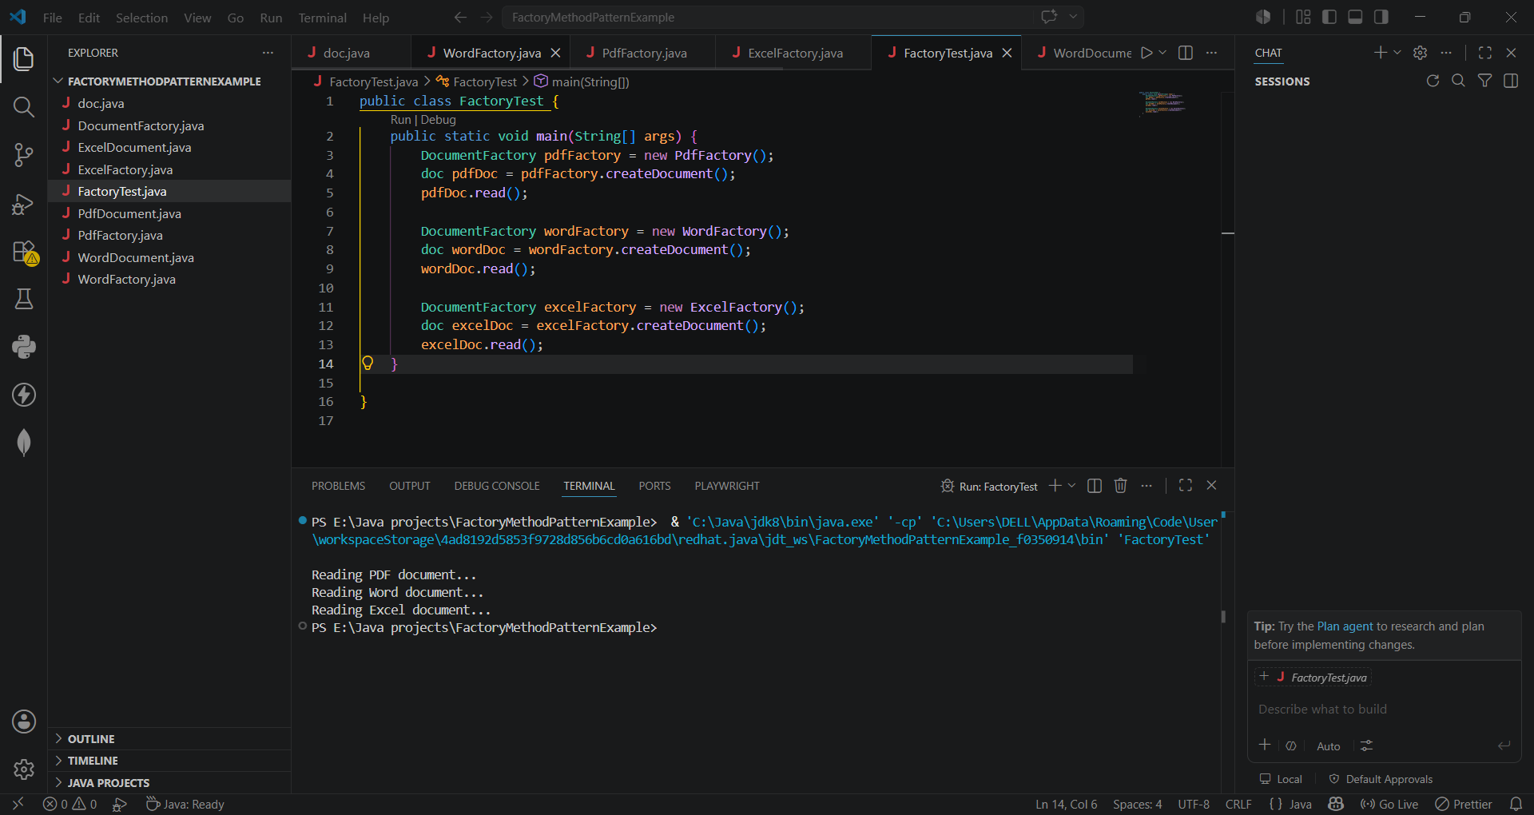
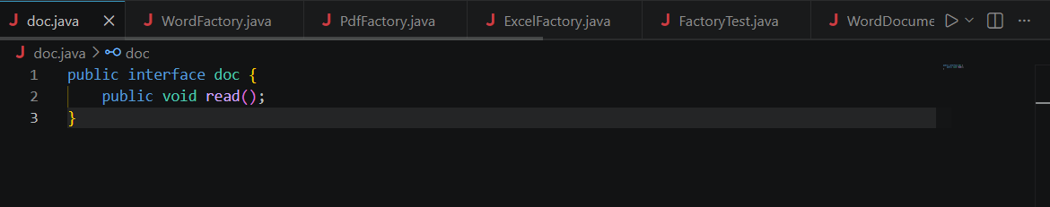
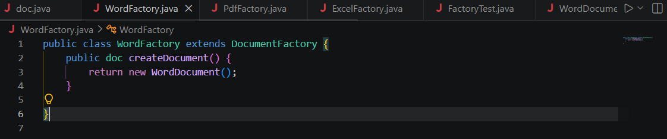
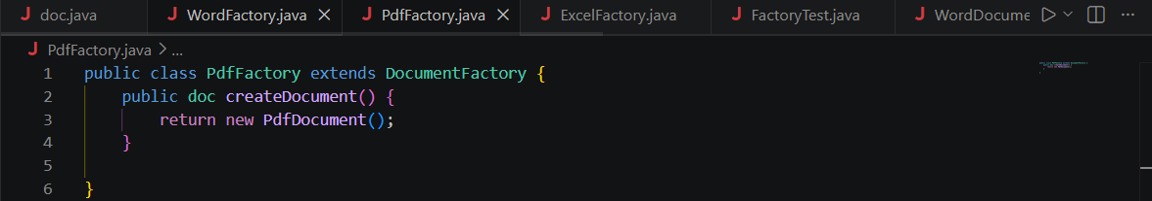
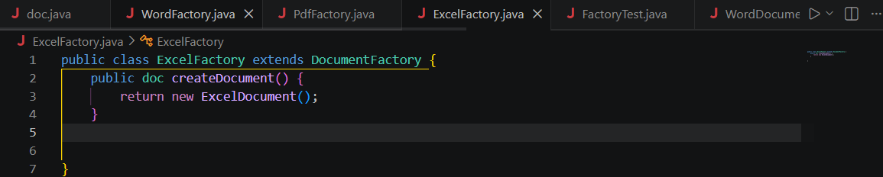
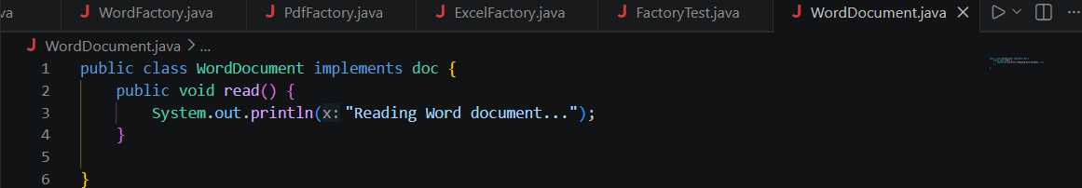
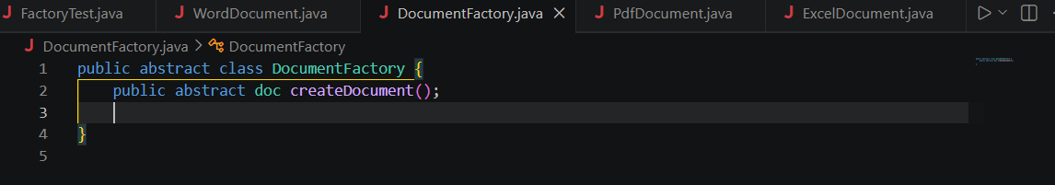
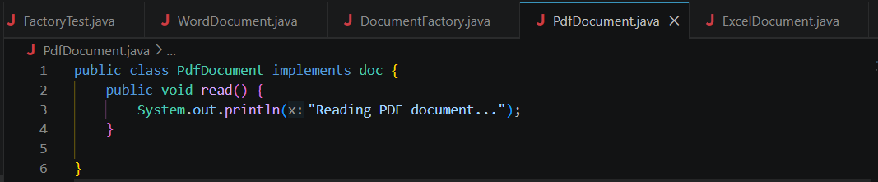
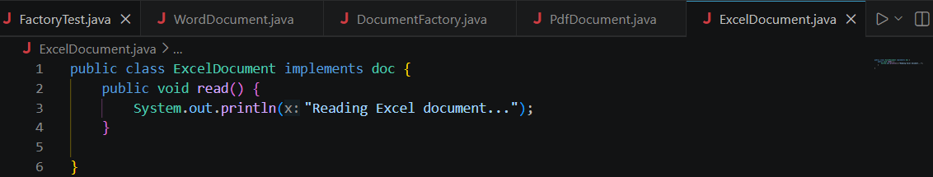

DSA
Exercise 2: E-commerce Platform Search Function
Scenario:
You are working on the search functionality of an e-commerce platform. The search needs to be optimized for fast performance.
Steps:
- Understand Asymptotic Notation:
  - Explain Big O notation and how it helps in analyzing algorithms.
  - Describe the best, average, and worst-case scenarios for search operations.
- Setup:
  - Create a class Product with attributes for searching, such as productId, productName, and category.
- Implementation:
  - Implement linear search and binary search algorithms.
  - Store products in an array for linear search and a sorted array for binary search.
- Analysis:
  - Compare the time complexity of linear and binary search algorithms.
  - Discuss which algorithm is more suitable for your platform and why.

Big O notation is used to describe the performance of an algorithm by measuring how its execution time grows as the input size increases.
Linear Search
- Best Case: Element found at the first position → O(1)
- Average Case: Element found in the middle → O(n)
- Worst Case: Element found at the last position or not found → O(n)
Binary Search
- Best Case: Element found at the middle position → O(1)
- Average Case: O(log n)
- Worst Case: O(log n)

class Product {
int ProductId;
String ProductName;
String Category;

Product(int ProductId, String ProductName, String Category) {
this.ProductId = ProductId;
this.ProductName = ProductName;
this.Category = Category;
}
}

public class Ecom {

static Product linearSearch(Product[] p, int id) {
for (Product x : p) {
if (x.ProductId == id)
return x;
}
return null;
}

static Product binarySearch(Product[] p, int id) {
int l = 0, r = p.length - 1;

while (l <= r) {
int m = (l + r) / 2;

if (p[m].ProductId == id)
return p[m];
else if (p[m].ProductId < id)
l = m + 1;
else
r = m - 1;
}
return null;
}

public static void main(String[] args) {

Product p1 = new Product(1, "Laptop", "Electronics");
Product p2 = new Product(2, "Shirt", "Clothing");
Product p3 = new Product(3, "Book", "Books");

Product[] products = {p1, p2, p3};

Product res1 = linearSearch(products, 2);

if (res1 != null)
System.out.println("Linear Search Found:");
System.out.println("ID: " + res1.ProductId);
System.out.println("Name: " + res1.ProductName);
System.out.println("Category: " + res1.Category);

Product res2 = binarySearch(products, 1);

if (res2 != null)
System.out.println("\nBinary Search Found:");
System.out.println("ID: " + res2.ProductId);
System.out.println("Name: " + res2.ProductName);
System.out.println("Category: " + res2.Category);
}
}

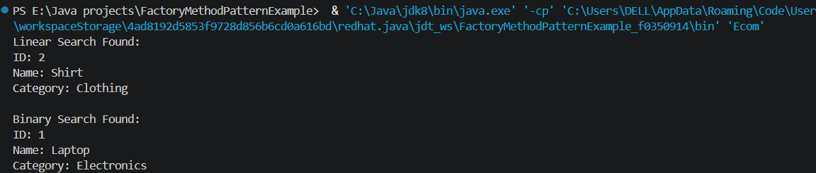
Binary Search is more suitable for an e-commerce platform because:
- It performs searches much faster on large datasets.
- It reduces the number of comparisons significantly.
- Its time complexity is O(log n) compared to O(n) for Linear Search.
- Most e-commerce platforms maintain indexed or sorted product data, making Binary Search practical.

Exercise 7: Financial Forecasting
Scenario:
You are developing a financial forecasting tool that predicts future values based on past data.
Steps:
- Understand Recursive Algorithms:
  - Explain the concept of recursion and how it can simplify certain problems.
- Setup:
  - Create a method to calculate the future value using a recursive approach.
- Implementation:
  - Implement a recursive algorithm to predict future values based on past growth rates.
- Analysis:
  - Discuss the time complexity of your recursive algorithm.
  - Explain how to optimize the recursive solution to avoid excessive computation.

Recursion is a programming technique in which a method calls itself to solve a problem. A recursive solution consists of:
- Base Case: Condition that stops recursion.
- Recursive Case: Function calls itself with a smaller problem.
Recursion simplifies problems that can be broken into smaller subproblems.
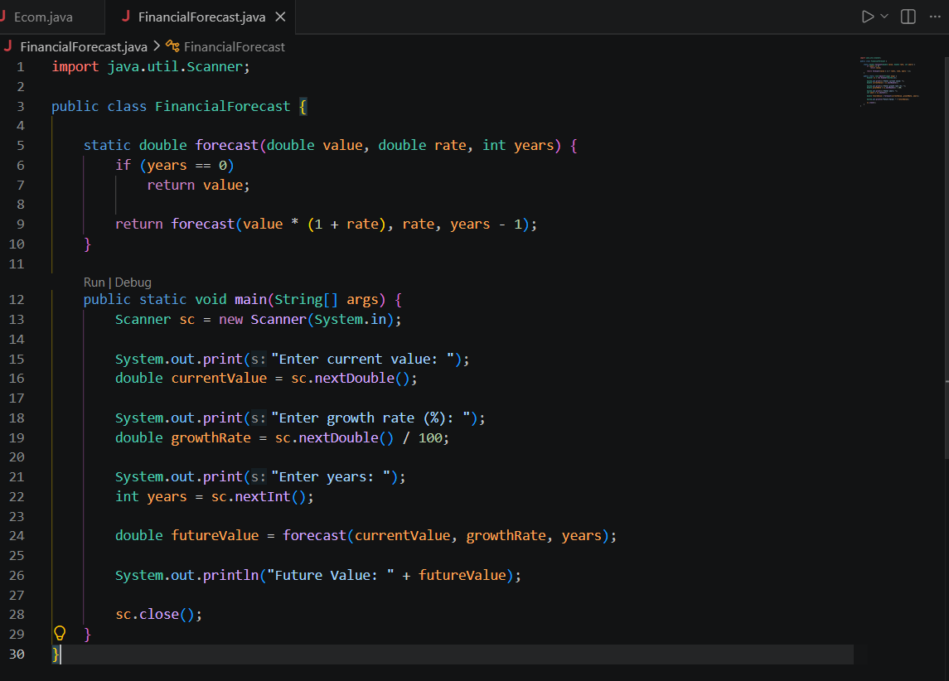
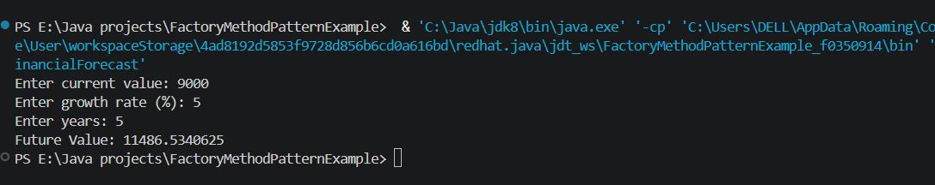
Time Complexity = O(n)

Space Complexity = O(n)
where n = number of years.

PL/SQL

Exercise 1: Control Structures

Scenario 1: The bank wants to apply a discount to loan interest rates for customers above 60 years old.
  - Question: Write a PL/SQL block that loops through all customers, checks their age, and if they are above 60, apply a 1% discount to their current loan interest rates.
Scenario 2: A customer can be promoted to VIP status based on their balance.
  - Question: Write a PL/SQL block that iterates through all customers and sets a flag IsVIP to TRUE for those with a balance over $10,000.
Scenario 3: The bank wants to send reminders to customers whose loans are due within the next 30 days.
  - Question: Write a PL/SQL block that fetches all loans due in the next 30 days and prints a reminder message for each customer.
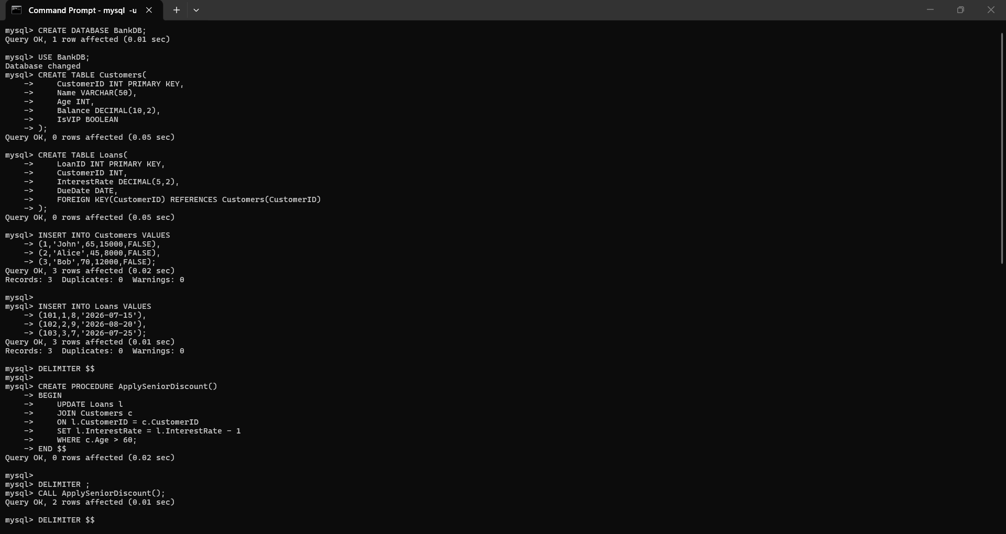
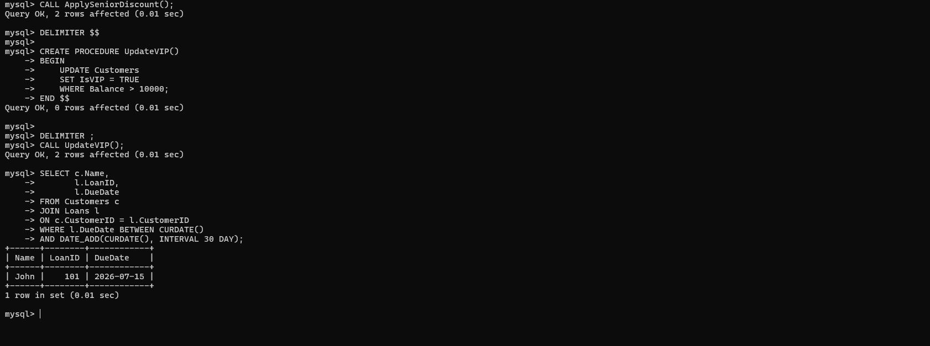
Exercise 3: Stored Procedures

Scenario 1: The bank needs to process monthly interest for all savings accounts.
  - Question: Write a stored procedure ProcessMonthlyInterest that calculates and updates the balance of all savings accounts by applying an interest rate of 1% to the current balance.

Scenario 2: The bank wants to implement a bonus scheme for employees based on their performance.
  - Question: Write a stored procedure UpdateEmployeeBonus that updates the salary of employees in a given department by adding a bonus percentage passed as a parameter.

Scenario 3: Customers should be able to transfer funds between their accounts.
  - Question: Write a stored procedure TransferFunds that transfers a specified amount from one account to another, checking that the source account has sufficient balance before making the transfer.

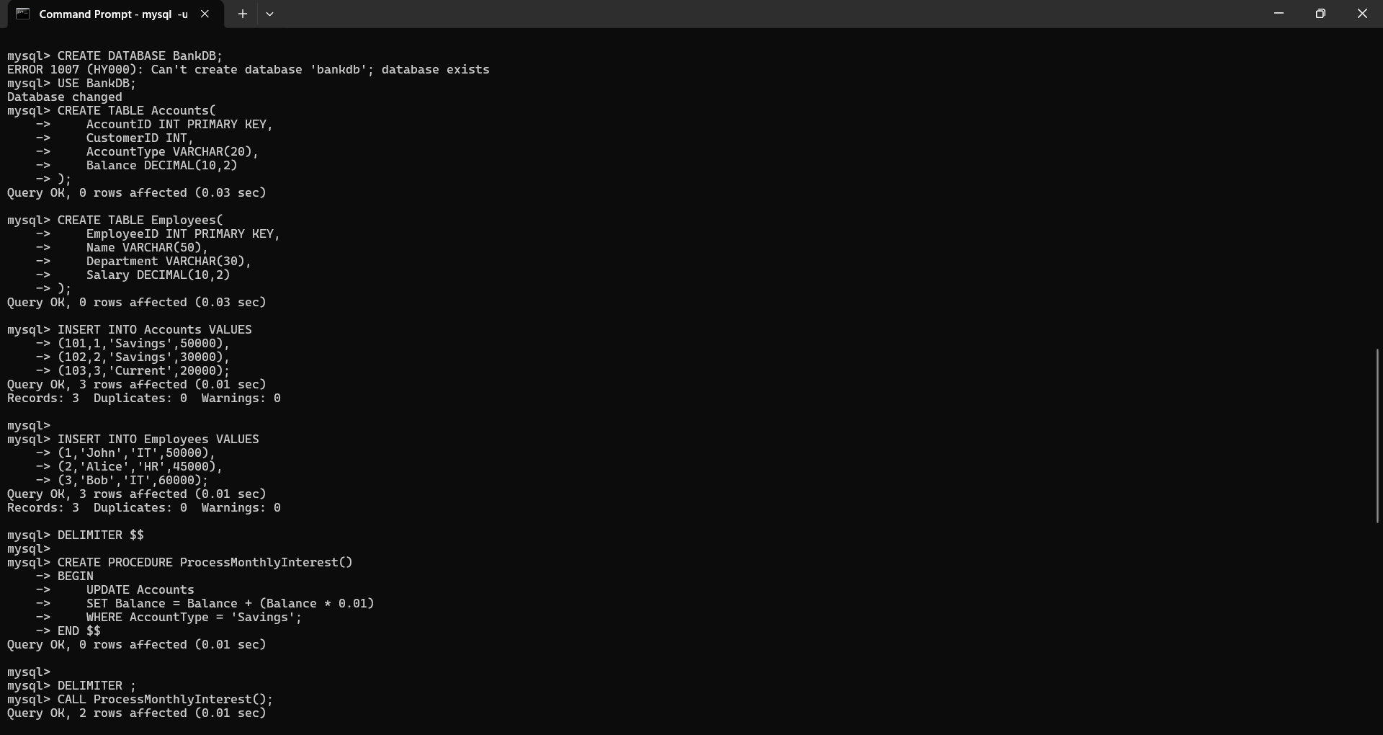
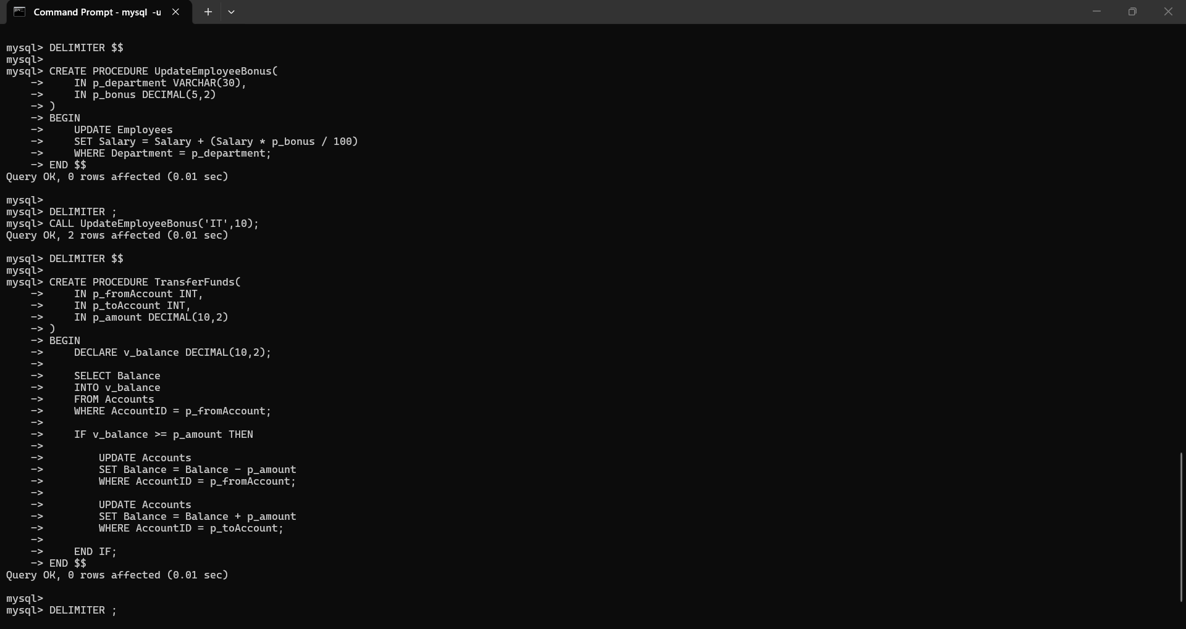

1. TDD using JUnit5 and Mockito
Exercise 1: Setting Up JUnit
Scenario:
You need to set up JUnit in your Java project to start writing unit tests.
Steps:
1. Create a new Java project in your IDE (e.g., IntelliJ IDEA, Eclipse).
2. Add JUnit dependency to your project. If you are using Maven, add the following to your
pom.xml:
<dependency>
<groupId>junit</groupId>
<artifactId>junit</artifactId>
<version>4.13.2</version>
<scope>test</scope>
</dependency>
3. Create a new test class in your project.

Exercise 3: Assertions in JUnit
Scenario:
You need to use different assertions in JUnit to validate your test results.
Steps:
1. Write tests using various JUnit assertions.
Solution Code:

public class AssertionsTest {
@Test
public void testAssertions() {
// Assert equals
assertEquals(5, 2 + 3);

// Assert true
assertTrue(5 > 3);

// Assert false
assertFalse(5 < 3);

// Assert null
assertNull(null);

// Assert not null
assertNotNull(new Object());
}
}

Exercise 4: Arrange-Act-Assert (AAA) Pattern, Test Fixtures, Setup and
Teardown Methods in JUnit
Scenario:
You need to organize your tests using the Arrange-Act-Assert (AAA) pattern and use setup
and teardown methods.
Steps:
1. Write tests using the AAA pattern.
2. Use @Before and @After annotations for setup and teardown methods.

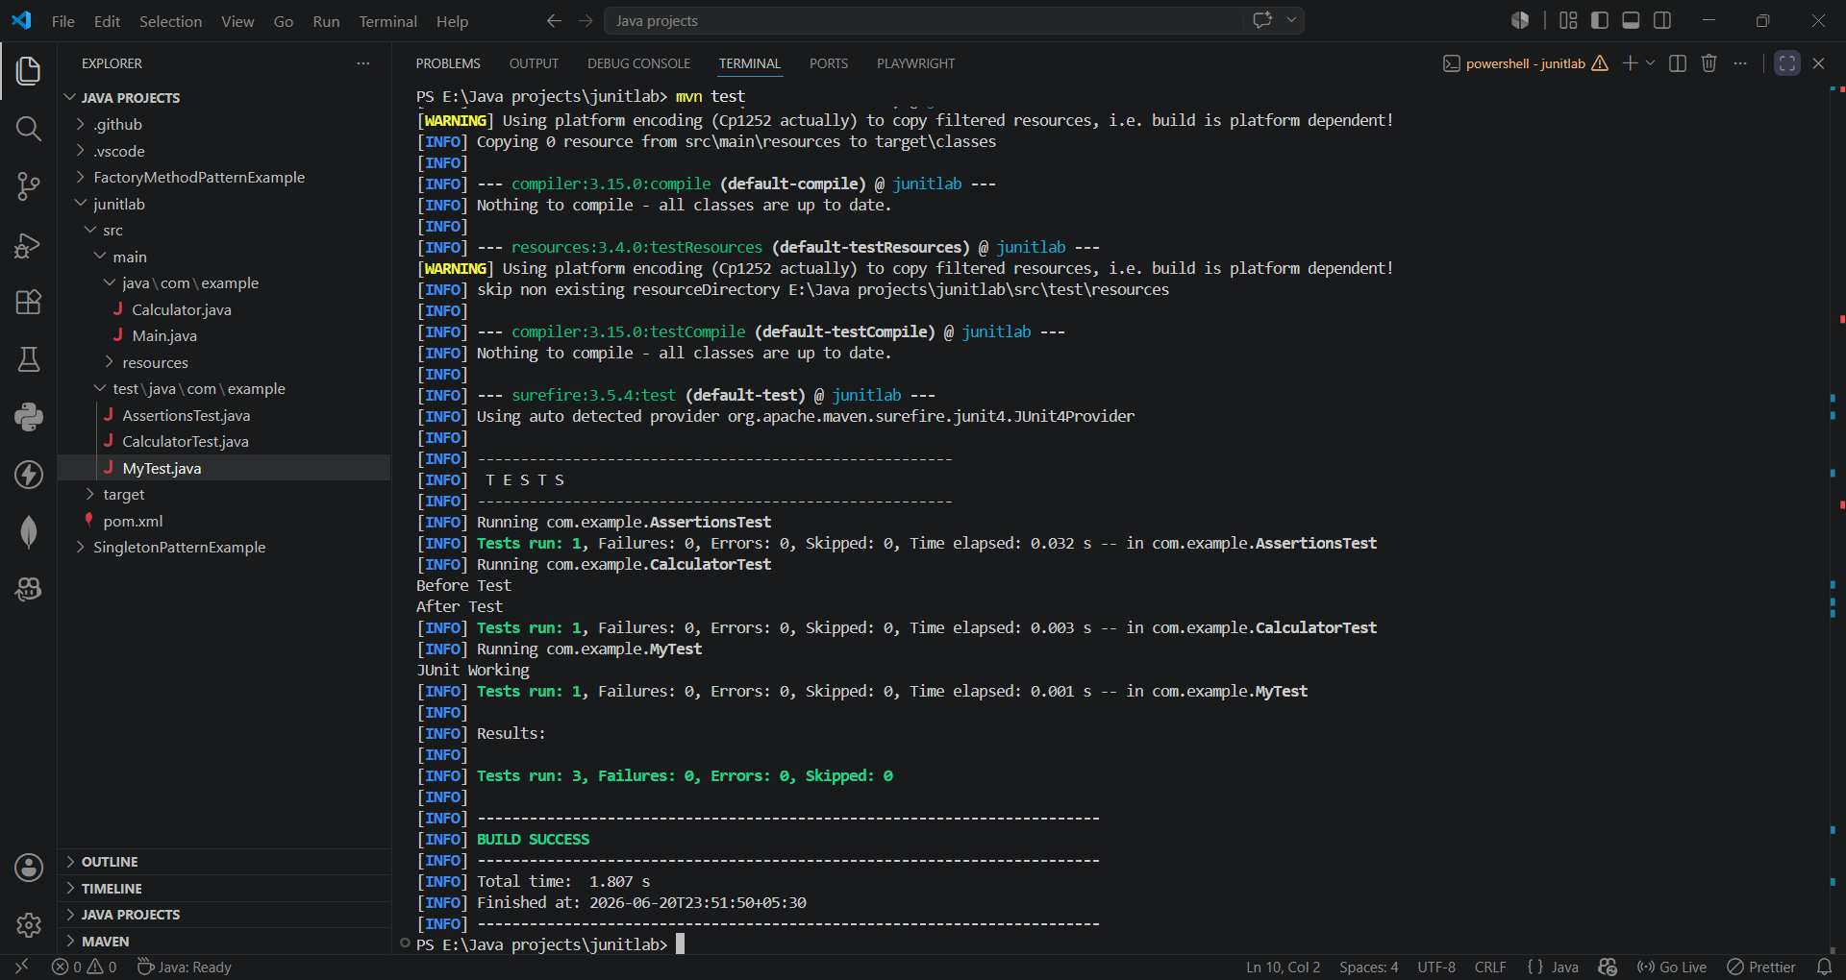
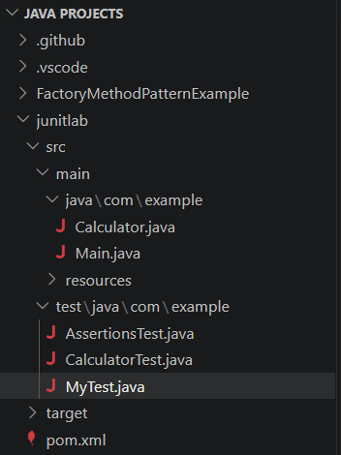
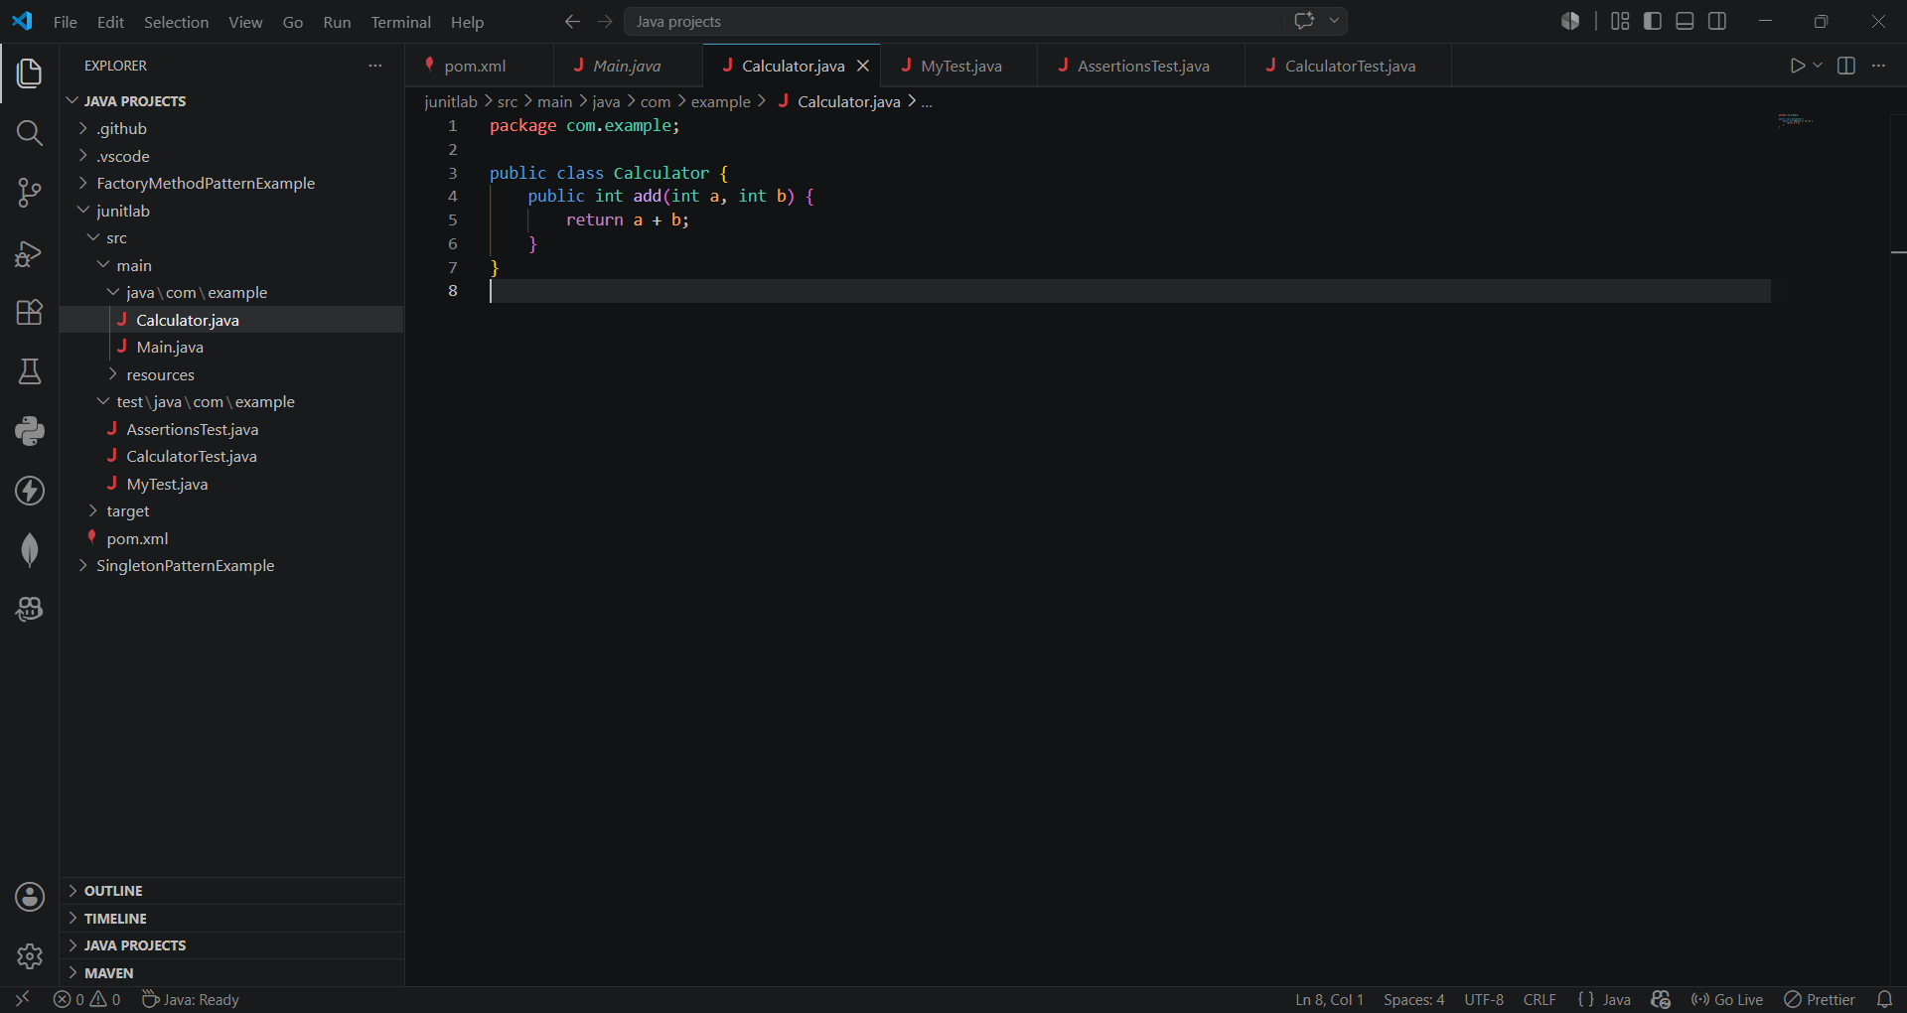
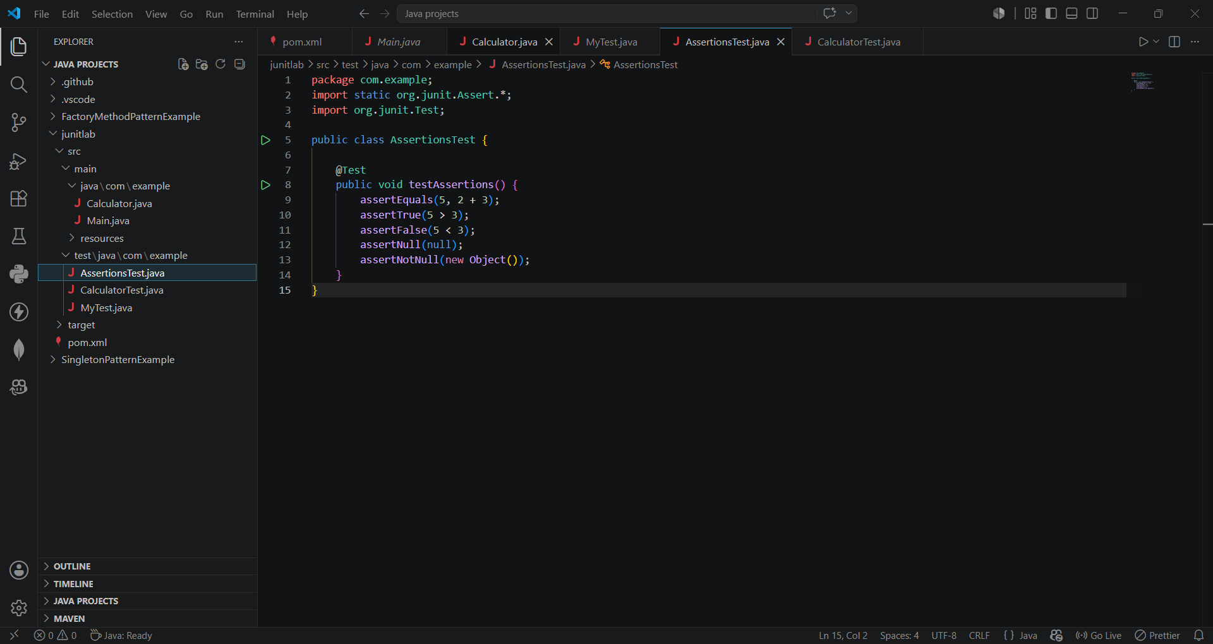
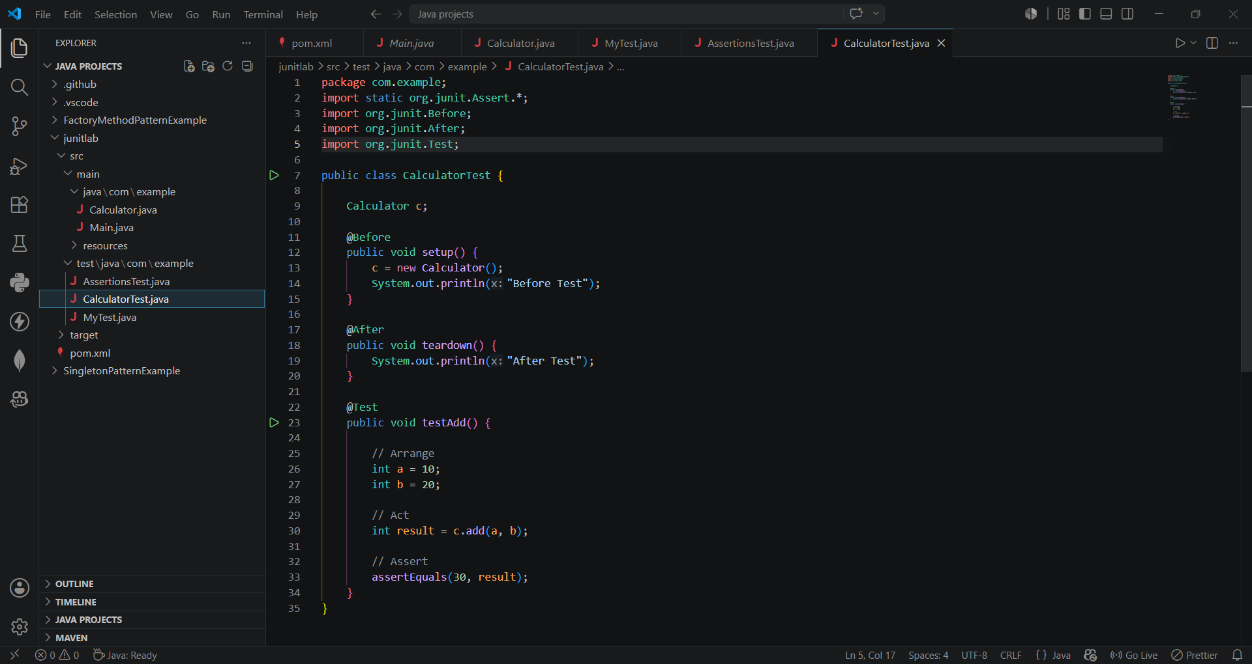

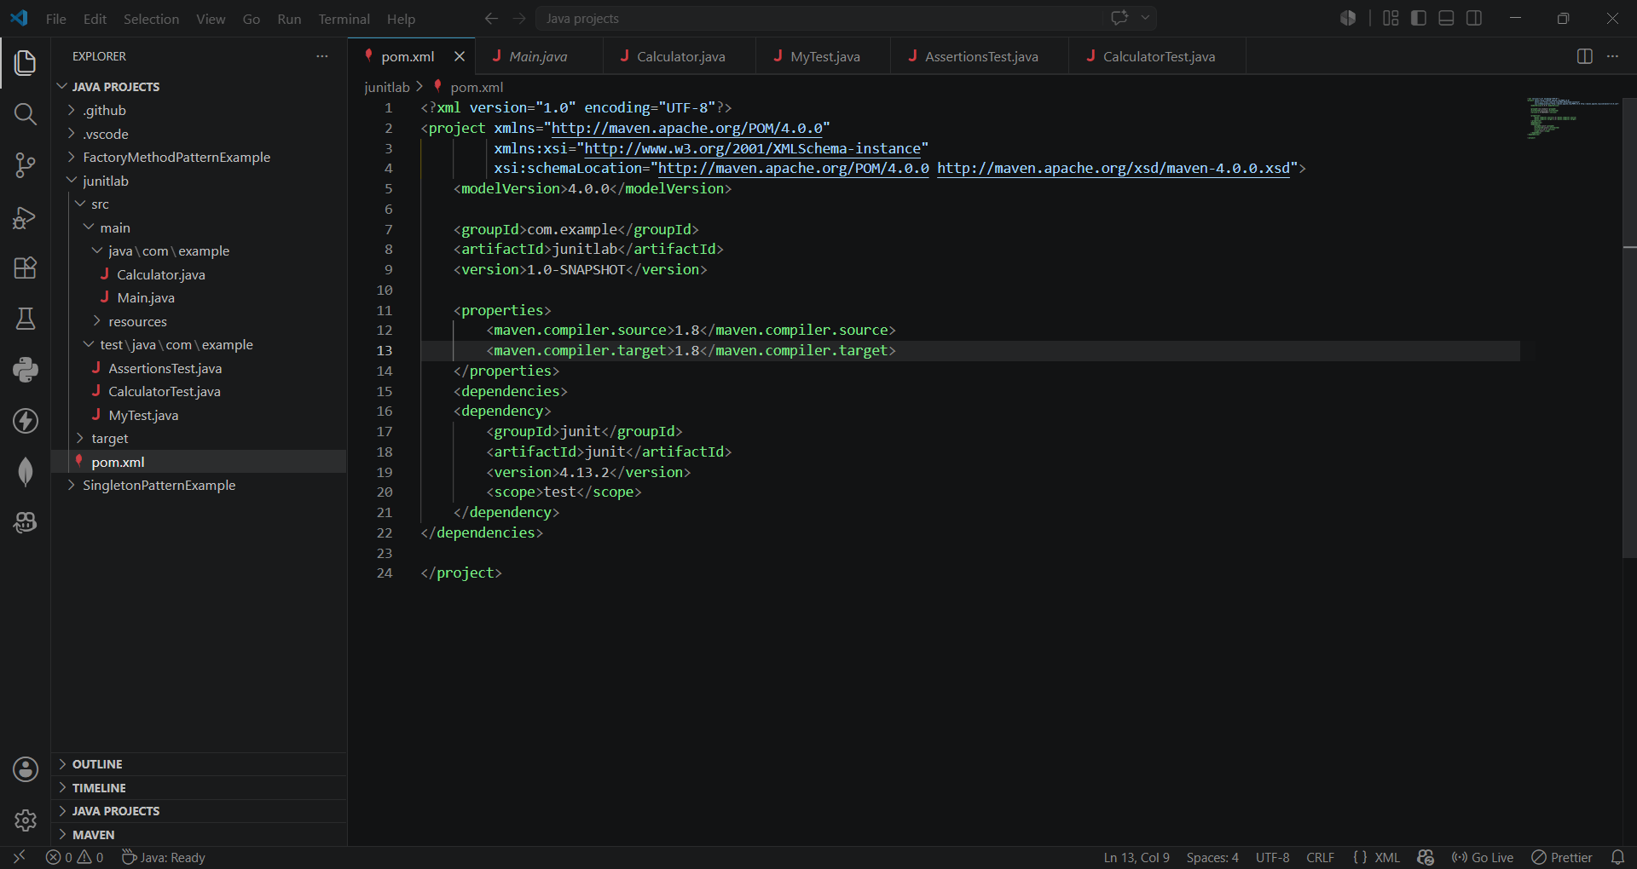
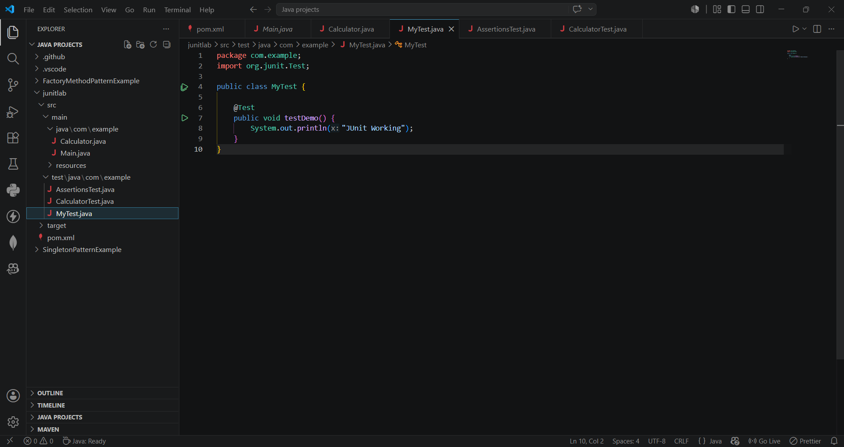
Exercise 1: Mocking and Stubbing
Scenario:
You need to test a service that depends on an external API. Use Mockito to mock the
external API and stub its methods.

Steps:
1. Create a mock object for the external API.
2. Stub the methods to return predefined values.
3. Write a test case that uses the mock object.

Solution Code:
import static org.mockito.Mockito.*;
import org.junit.jupiter.api.Test;
import org.mockito.Mockito;

public class MyServiceTest {
@Test
public void testExternalApi() {
ExternalApi mockApi = Mockito.mock(ExternalApi.class);
when(mockApi.getData()).thenReturn("Mock Data");
MyService service = new MyService(mockApi);
String result = service.fetchData();
assertEquals("Mock Data", result);
}
}

Exercise 2: Verifying Interactions
Scenario:
You need to ensure that a method is called with specific arguments.

Steps:
1. Create a mock object.
2. Call the method with specific arguments.
3. Verify the interaction.

Solution Code:
import static org.mockito.Mockito.*;
import org.junit.jupiter.api.Test;
import org.mockito.Mockito;

public class MyServiceTest {
@Test
public void testVerifyInteraction() {
ExternalApi mockApi = Mockito.mock(ExternalApi.class);
MyService service = new MyService(mockApi);
service.fetchData();
verify(mockApi).getData();
}
}

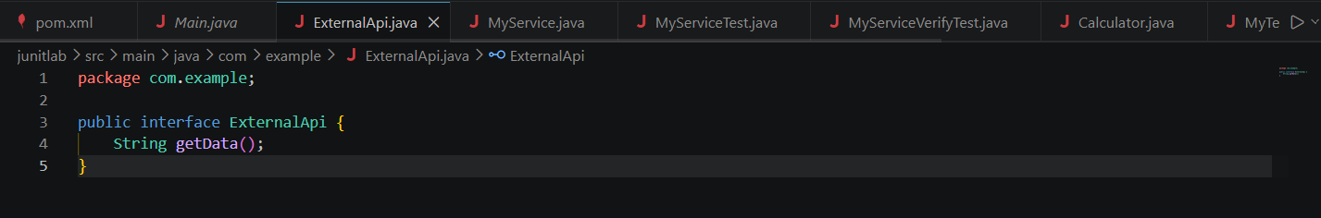

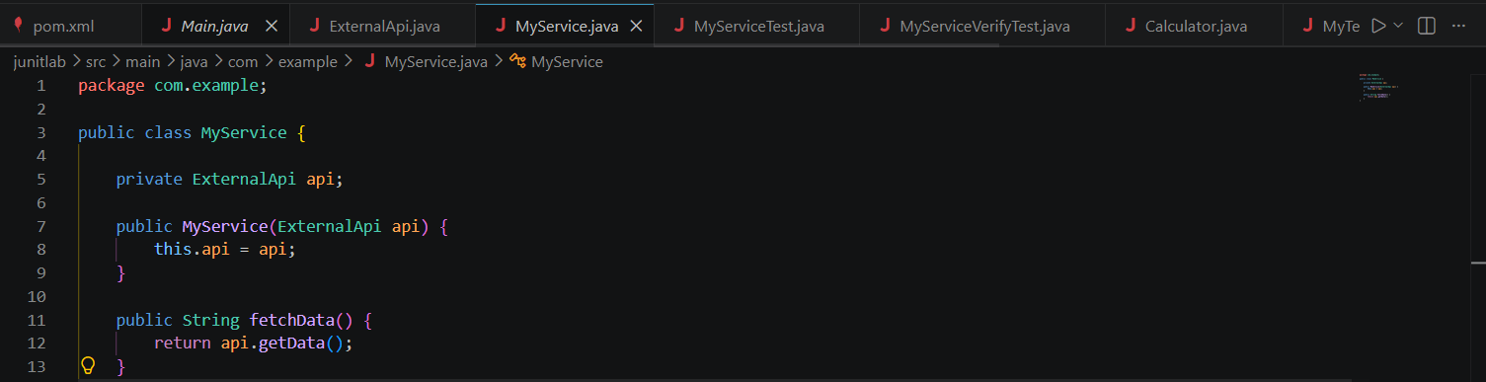
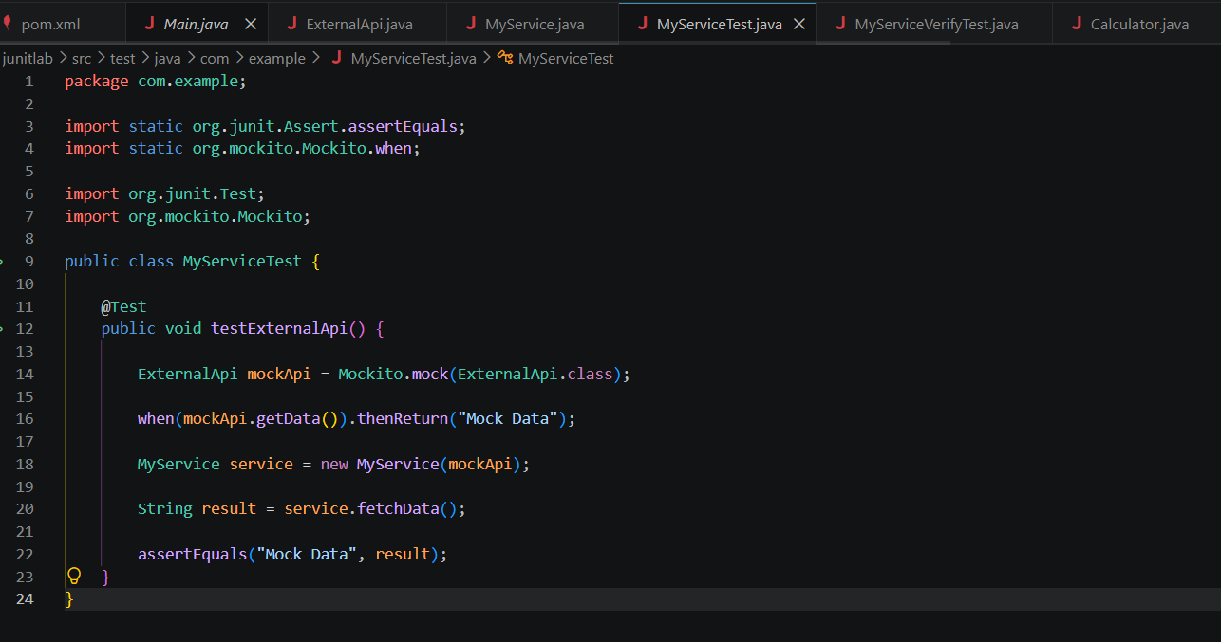

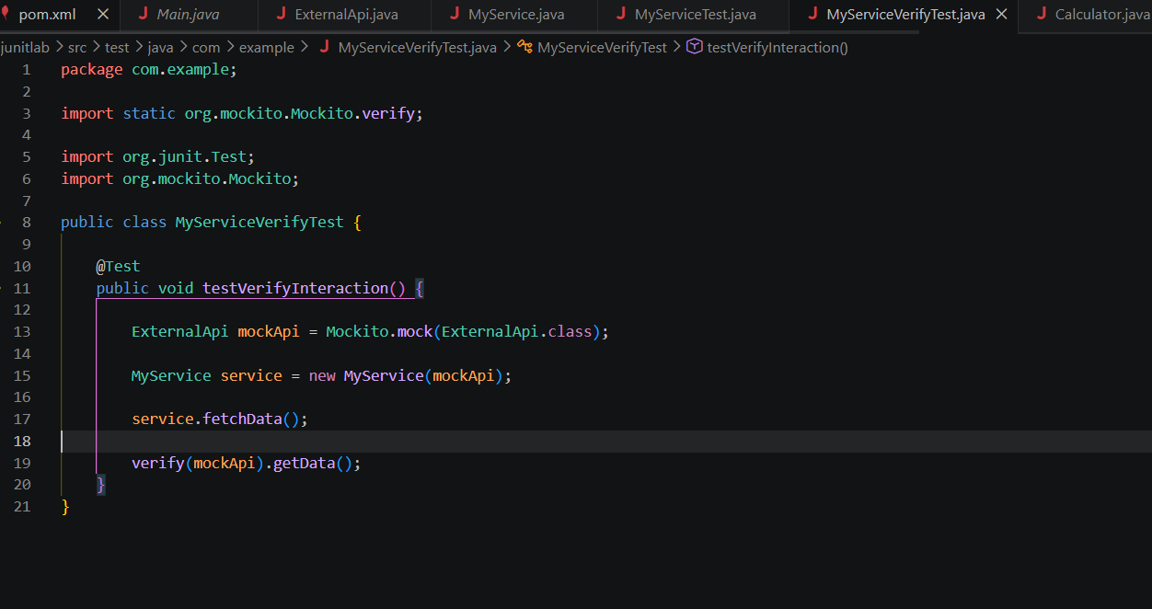
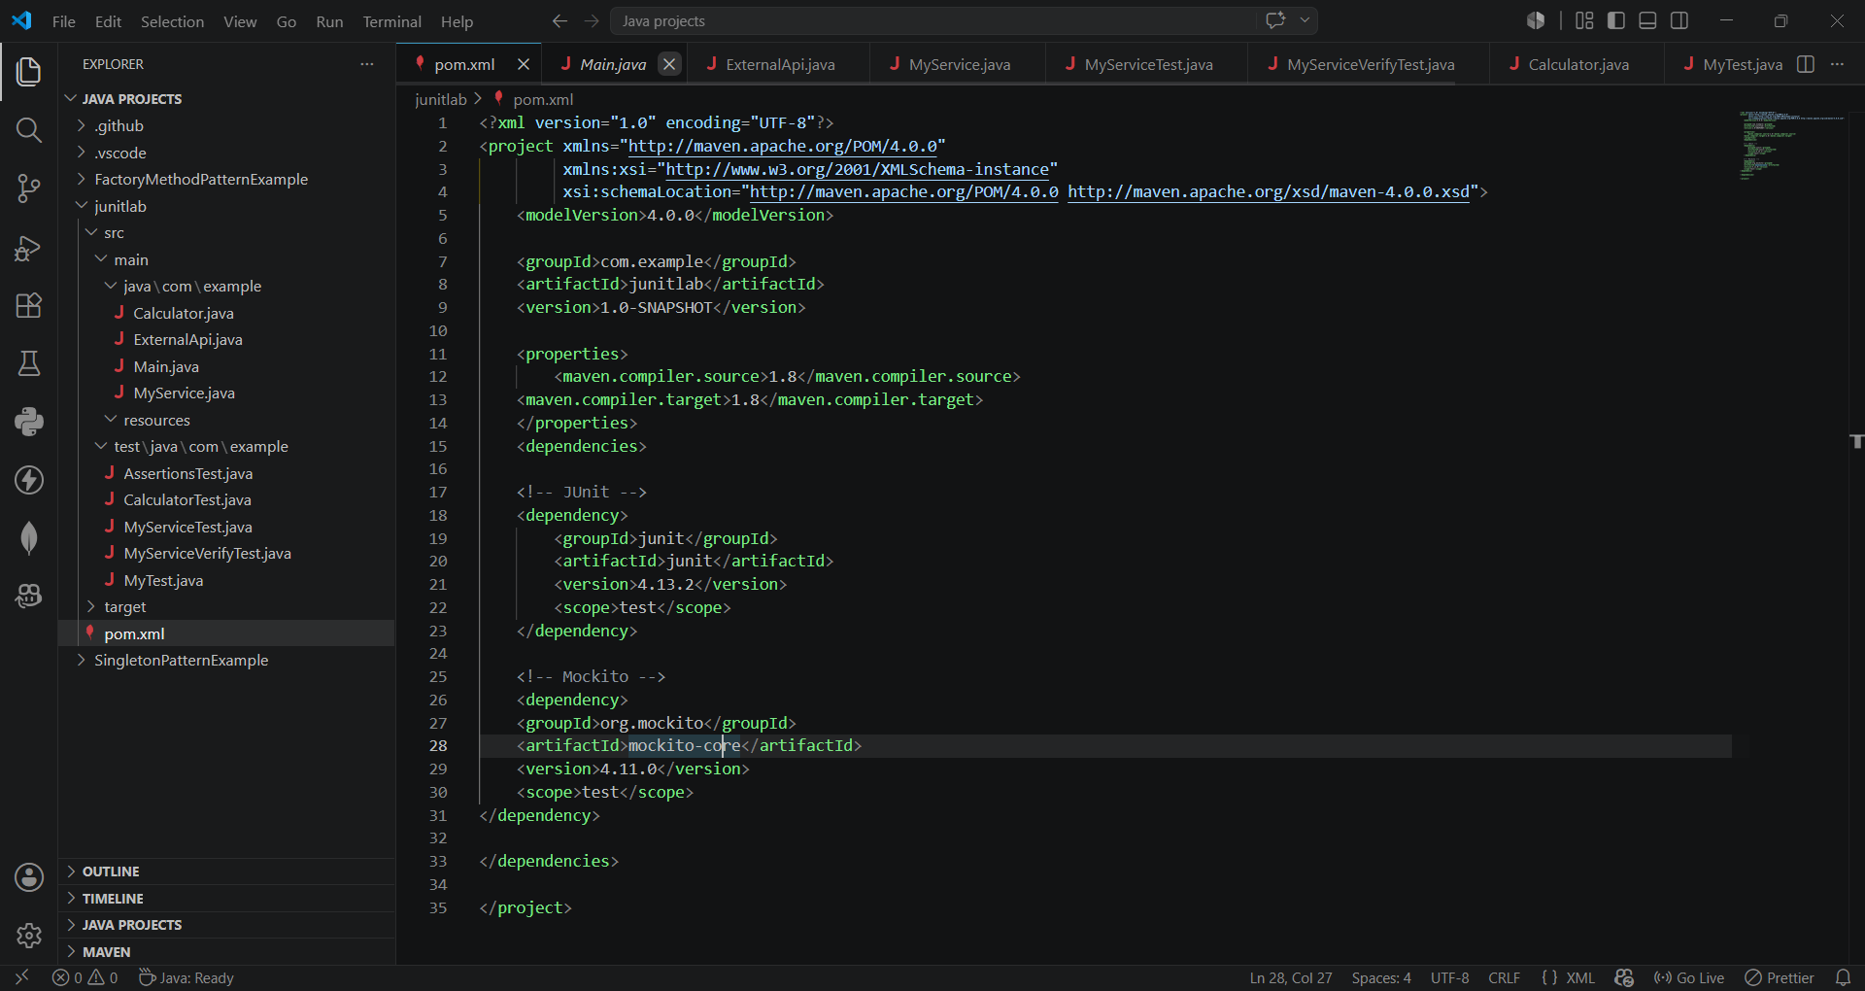

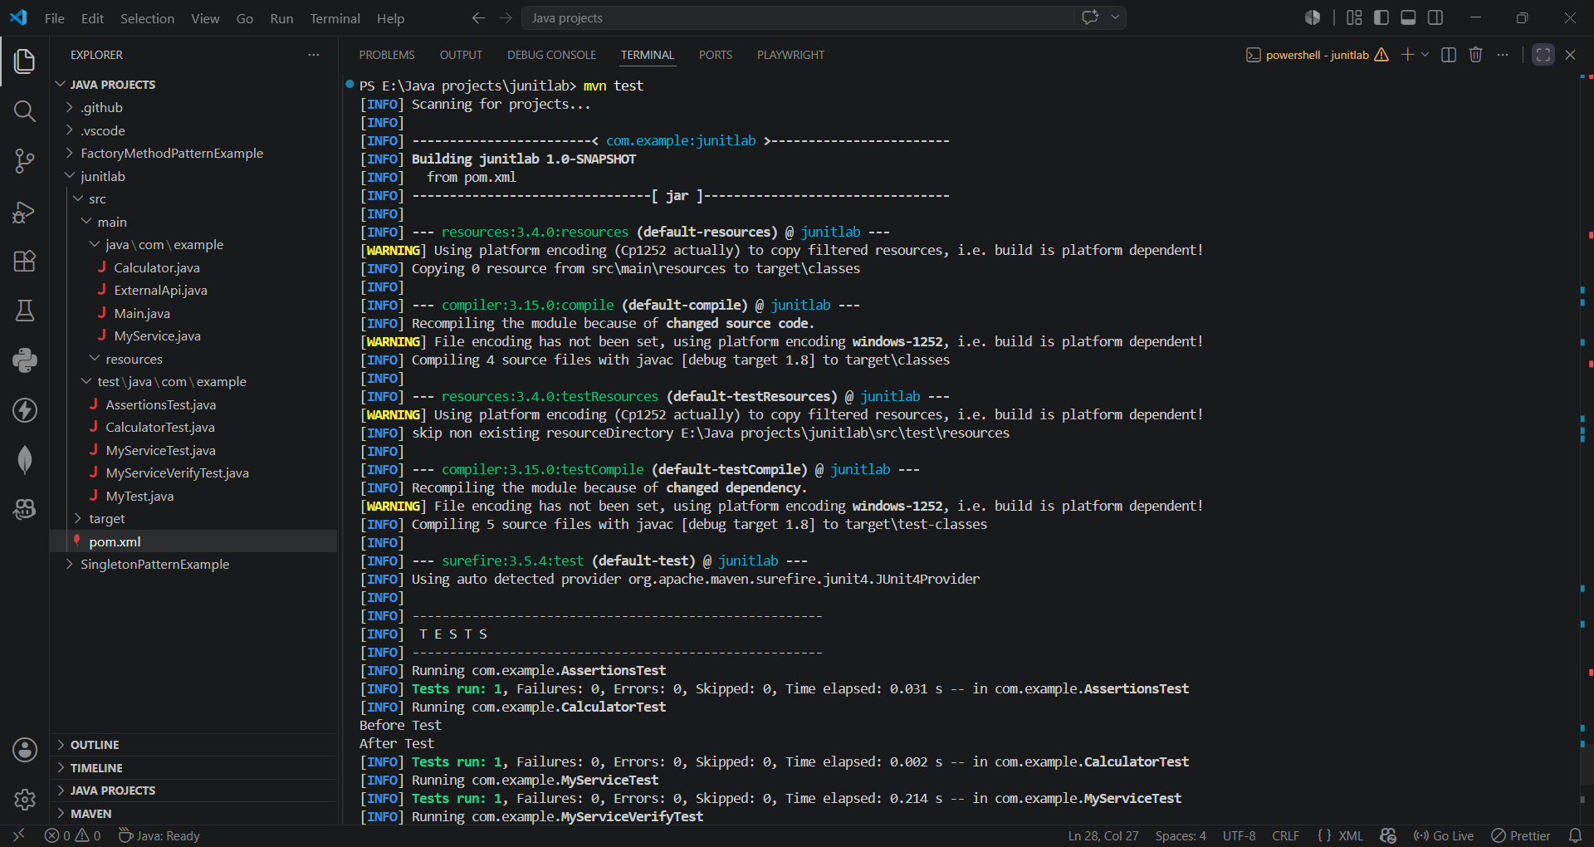

SLF4J logging framework
Exercise 1: Logging Error Messages and Warning Levels
Task: Write a Java application that demonstrates logging error messages and warning levels
using SLF4J.
Step-by-Step Solution:
1. Add SLF4J and Logback dependencies to your `pom.xml` file:
<dependency>
<groupId>org.slf4j</groupId>
<artifactId>slf4j-api</artifactId>
<version>1.7.30</version>
</dependency>
<dependency>
<groupId>ch.qos.logback</groupId>
<artifactId>logback-classic</artifactId>
<version>1.2.3</version>
</dependency>
2. Create a Java class that uses SLF4J for logging:
import org.slf4j.Logger;
import org.slf4j.LoggerFactory;

public class LoggingExample {
private static final Logger logger = LoggerFactory.getLogger(LoggingExample.class);

public static void main(String[] args) {
logger.error("This is an error message");
logger.warn("This is a warning message");
}
